**5.SYSTEM DESIGN**

**5.1 Database Design:**

**5.1.1 Data flow digrams:**

**1)Use Case Digram:**

Login

Register

Issue book

View fine

**Student**

Add book

**Admin**

Download notes

**teacher**

Upload notes

View notes

Add book to wishlist

**:**

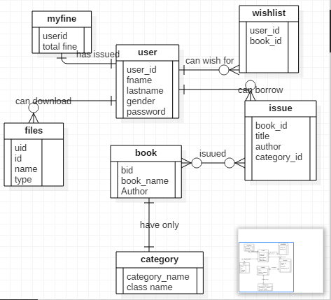

**6.SCREENSHOTS**

**2)Student Website:**

**Index.php**

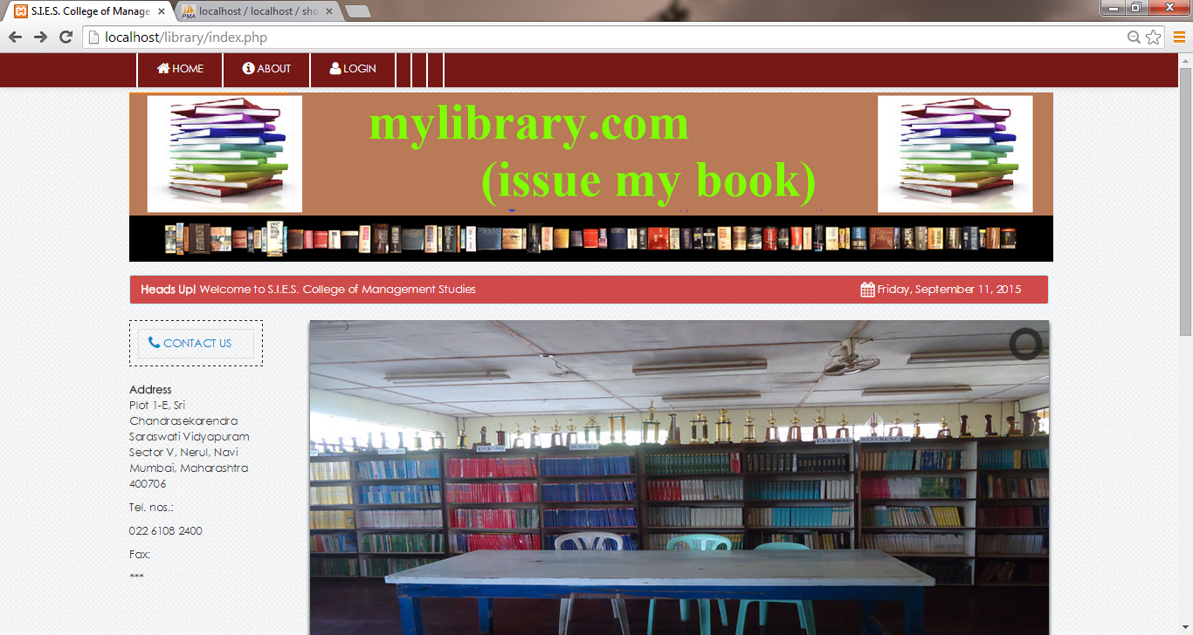

**Login.php**

**Home.php**

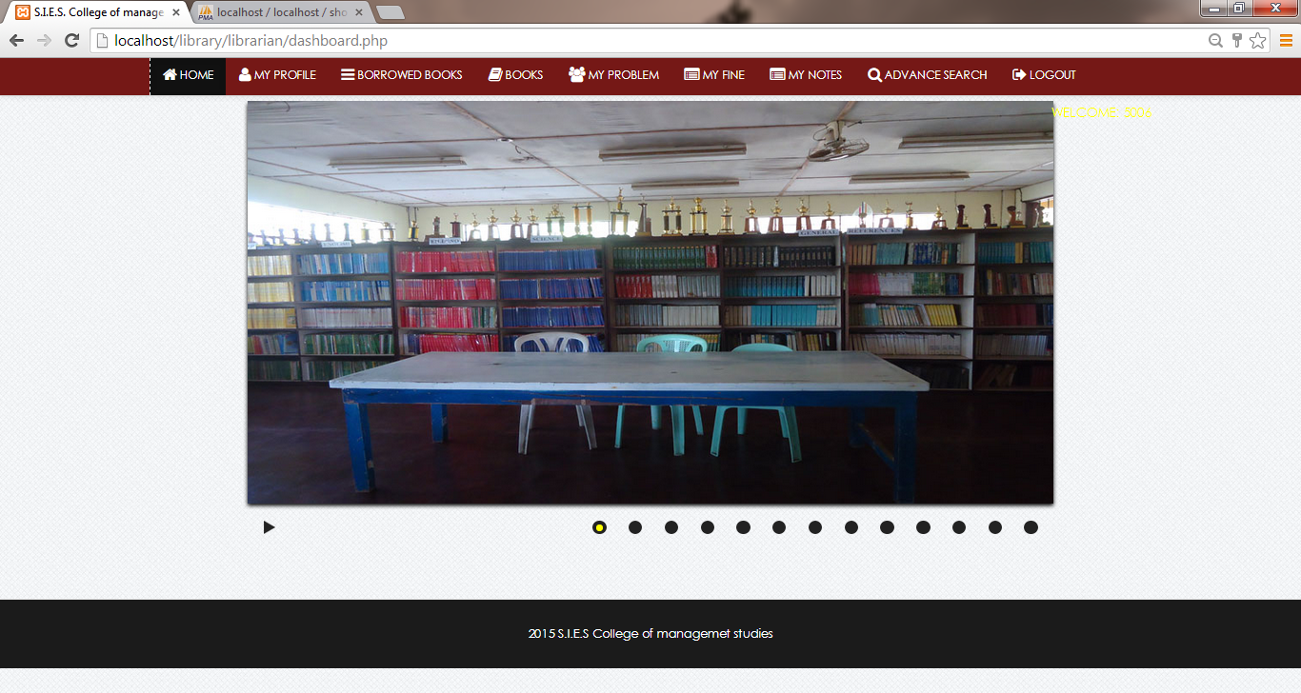

**Myprofile.php**

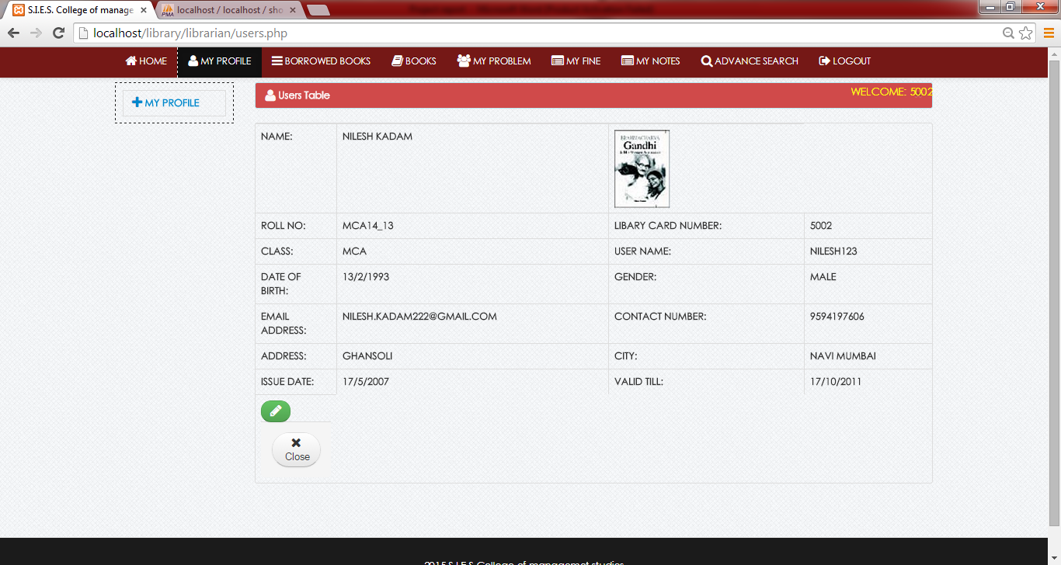

**View_borrow.php**

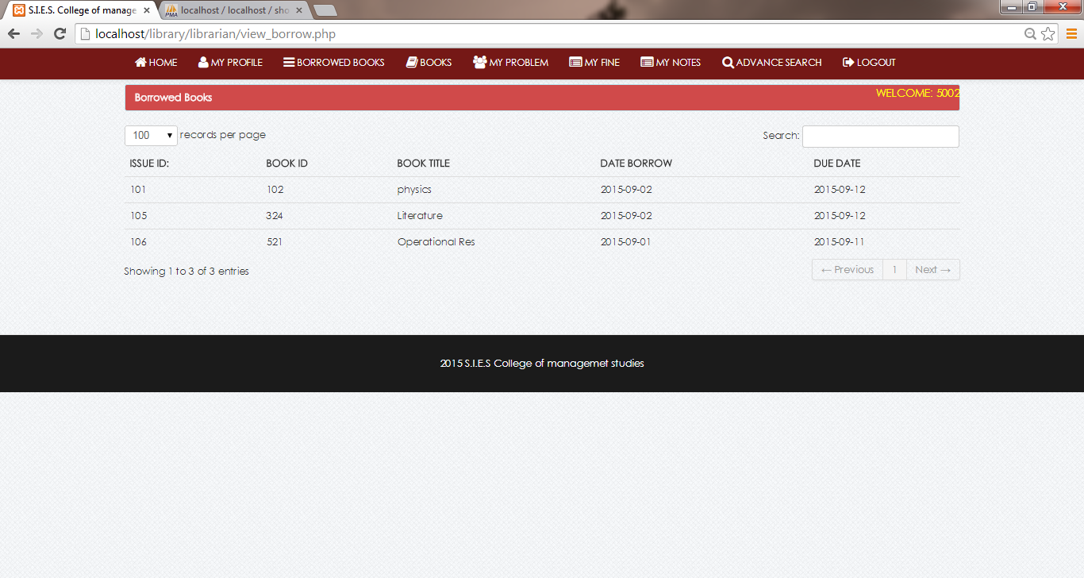

**Search.php**

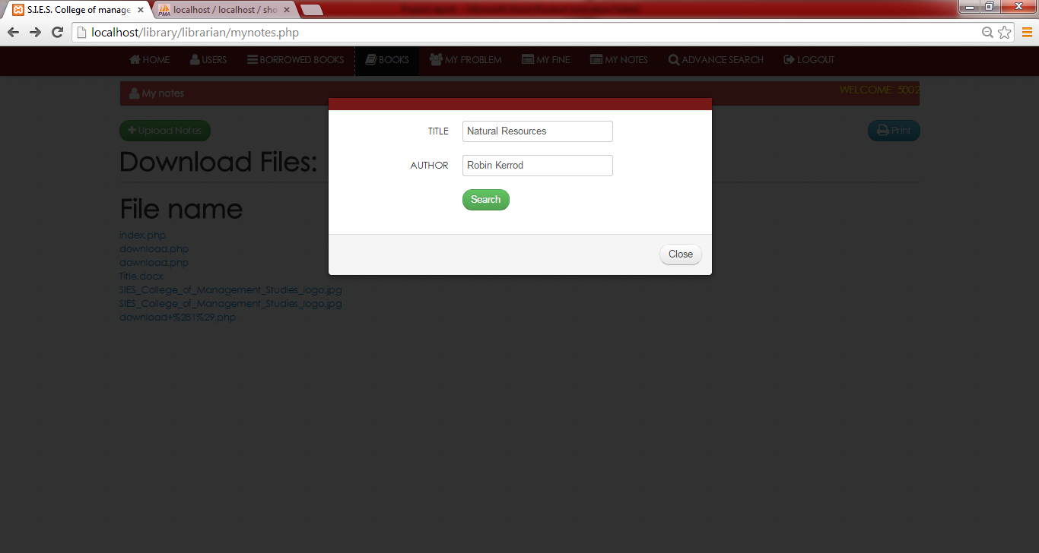

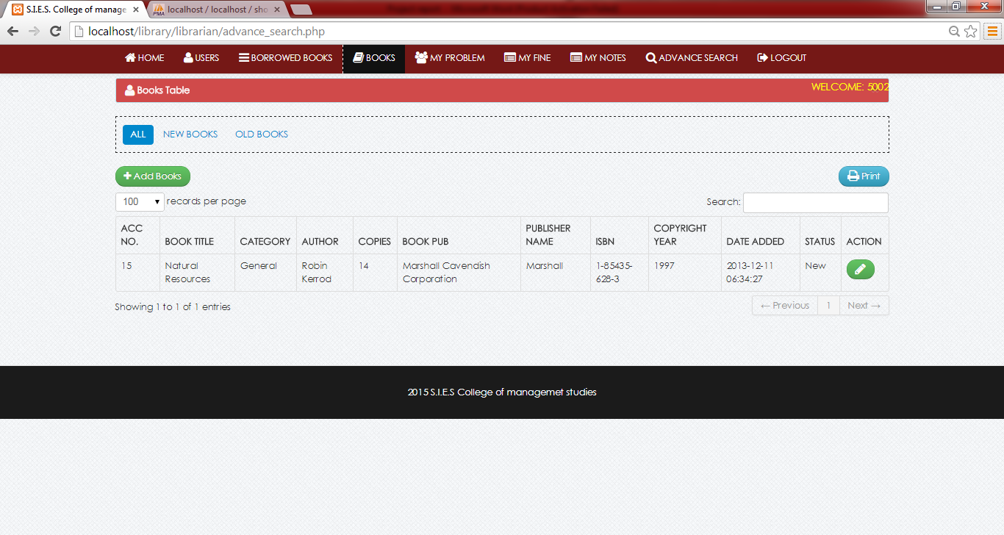

**Myfine.php**

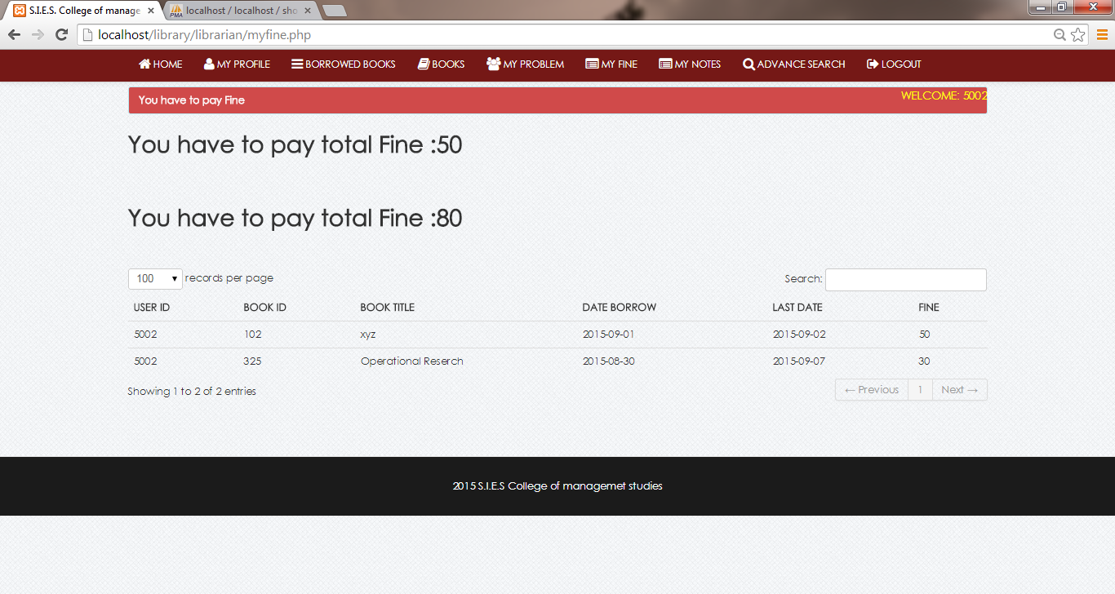

**Myproblem.php**

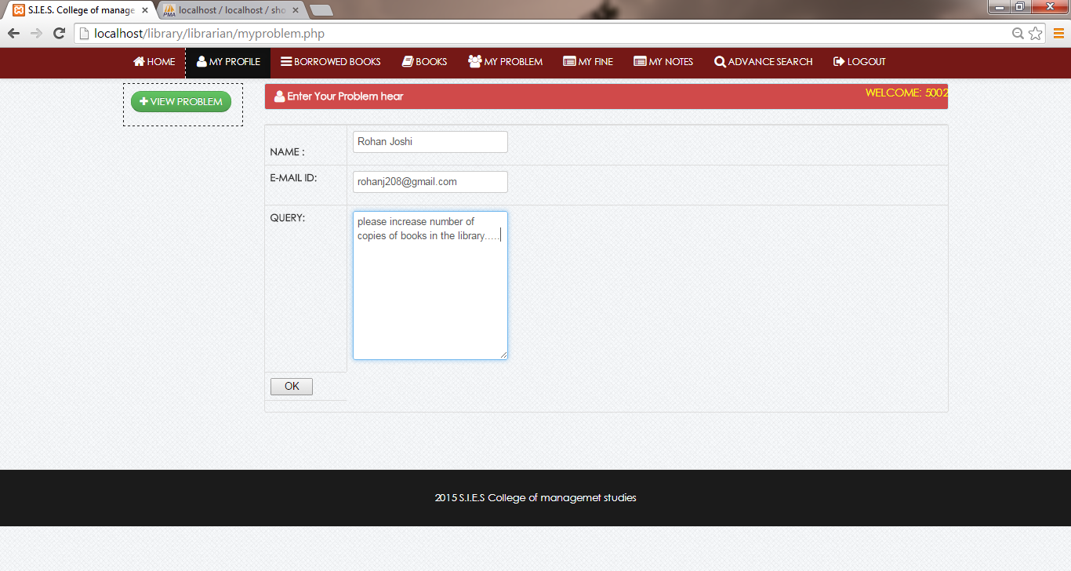

**3)Teacher Website:**

**Home.php:**



**Myprofile.php**



**Upload.php**

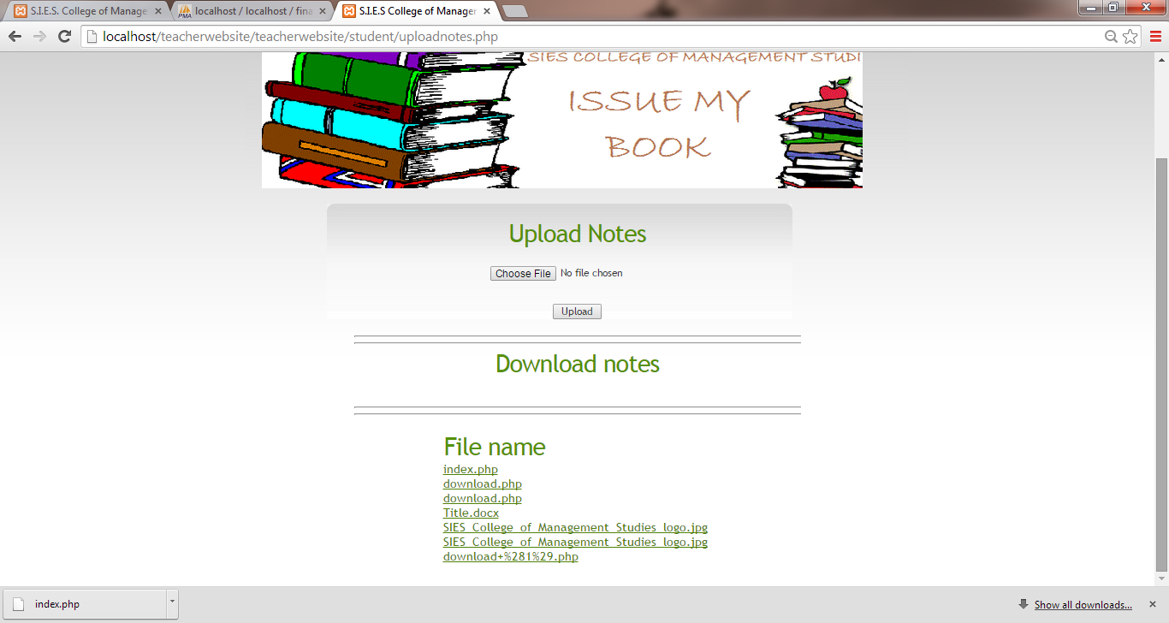

**Problem.php**

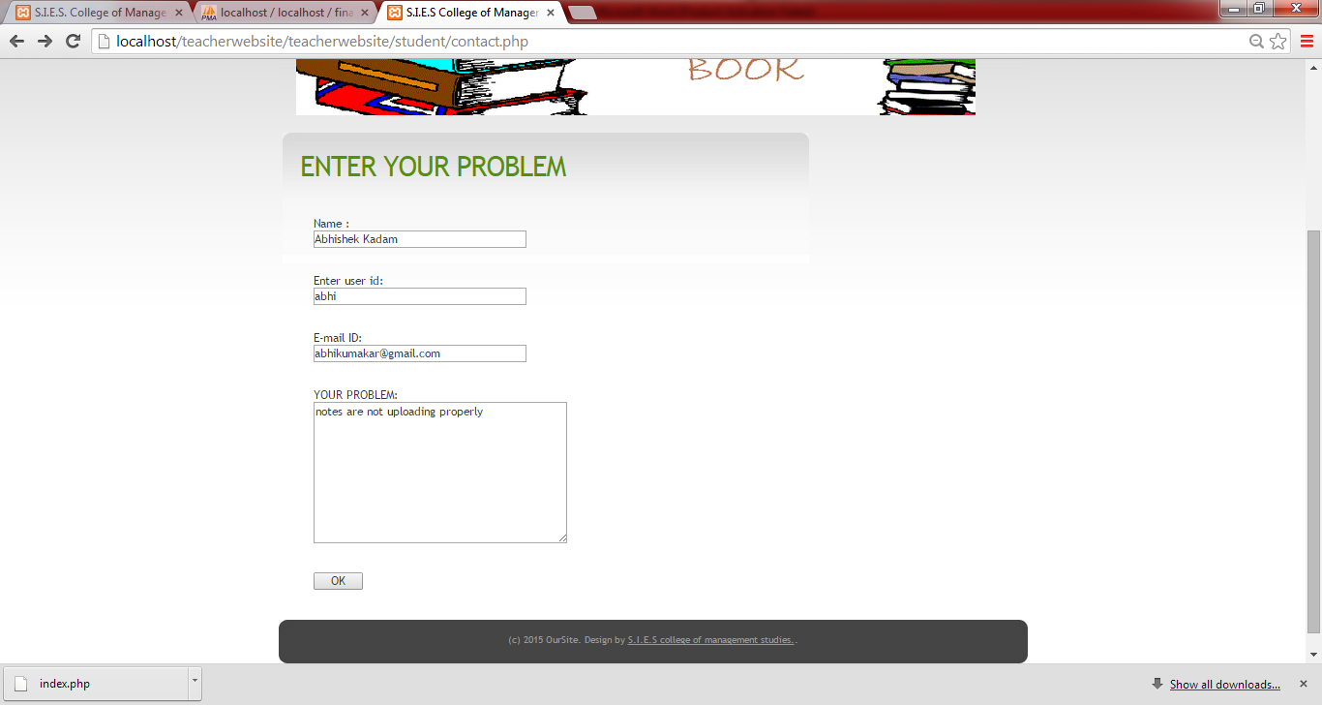

**7.FUTURE ENHANCEMENTS**

**1)We are developing an android app for the website. So students who have android phones can access their account through this app.**

**7.BILBIOGRAPHY & REFERENCES**

**Bilbiography and references:**

Books:

Webtechnologies(K.Roy)

PHP the complete reference(Holzerner)

* Online References

1. [www.google.com](http://www.google.com)
2. [www.tutorials-point.com](http://www.tutorials-point.com)
3. www.w3school.com
4. youtube.com
5. www.phpreferencebook.com